**REGULAR EXPRESSION IN C#**

* pattern that could be matched against an input text
* Add “Using System.Text.RegularExpression;”

Regular Expression Pattern 

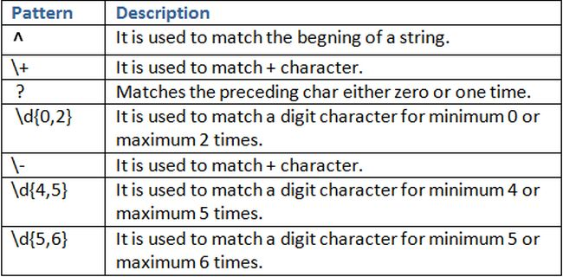

**Quantifiers -> *?+**

1. * => Matches the preceding character zero or more times.  
   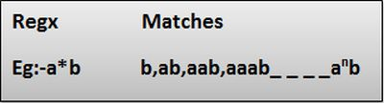
2. + => Matches the preceding character 1 or more times.  
   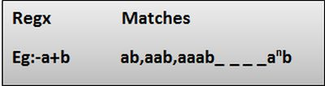
3. ? => Matches the preceding char zero or one time.  
     
   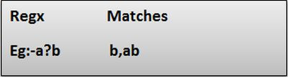

**Special characters:**

^ => It is used to match the beginning of a string  
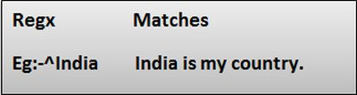

1. $=> It is used to match the end of a string.  
   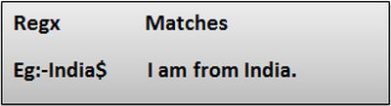
2. (Dot) => Matches any character only once.  
   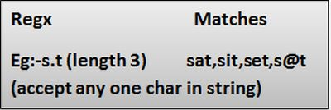
3. \d => It is used to match a digit char  
   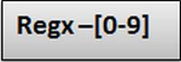
4. \D => It is used to match any non-digit character.  
   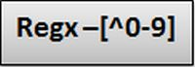
5. \w => It is used to match an alphanumeric character plus "_"  
   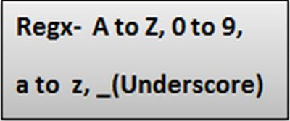
6. \W => It is used to match any non-word character.  
   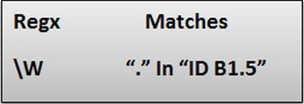
7. \s => Matches white space characters.  
   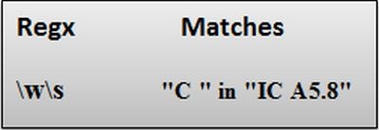
8. \S => Matches a non-white space character.  
     
   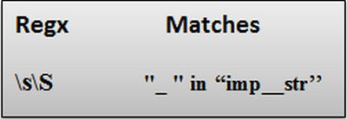

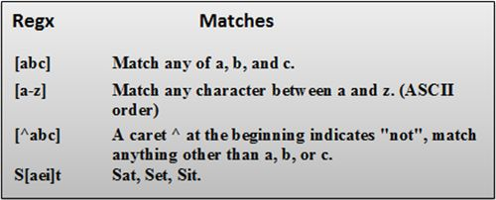

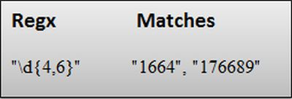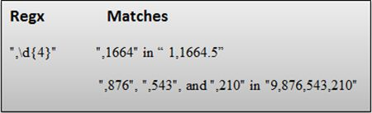

Creating Regex :

Regex rg = **new** Regex(pattern);

Find matching string with beginning letter “m”

1. **string** pattern = @"\b[m]\w+";
2. // Create a Regex
3. Regex rg = **new** Regex(pattern, RegexOptions.IgnoreCase);

Regexoptions.ignorecase ignore both lower and upper

1. Matches()
2. Replace()